|  |  |  |  |  |  |  |  |  |  |  |  |
| --- | --- | --- | --- | --- | --- | --- | --- | --- | --- | --- | --- |
|  | PRICE | Youth SM | Youth M | Youth L | Adult Sm | Adult M | Adult L | Adult XL | Adult 2X-  Add  $3.00 | Adult 3X-add $3.00 | TOTAL |
| **Dri Fit 100 Polyester**  **SWEAT SHIRT** | $24.00 |  |  |  |  |  |  |  |  |  |  |
| **Short Sleeve T-Shirt** | $ 9.00 |  |  |  |  |  |  |  |  |  |  |
| **Black Track Pants 100% Polyester** | $24.00 |  |  |  |  |  |  |  |  |  |  |
|  |  |  |  |  |  |  |  |  |  | **GRAND TOTAL** |  |

**Hilltop Spirit Wear Order Form**

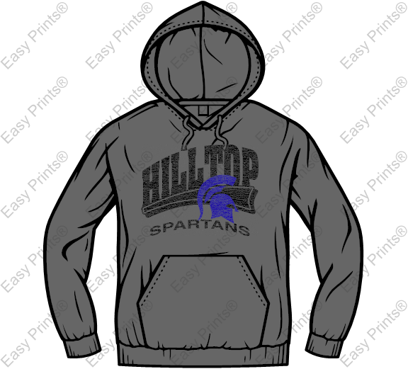

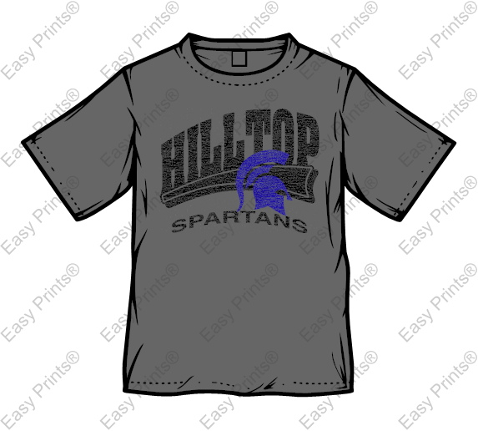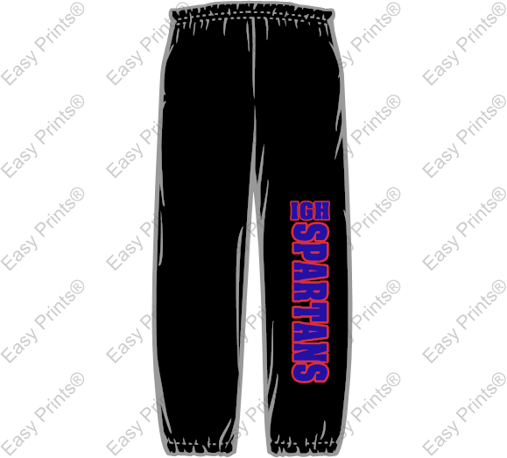

**Hilltop Spirit Wear is here!**

**Student name:_____________________________ Teacher and grade:_________________________**

This year we are offering three items. Both the t-shirt and hoodie will be dark gray and the track pants will be black. See photos for design. Please remember when ordering there is no return or exchanges. **ALL SALES ARE FINAL.** Orders are due on October 9th 2015. No late orders will be taken and they will be returned to the student’s teacher.

Please attach order form to an envelope containing cash or check labeled “Hilltop Spirit wear”. Checks made out to Hilltop PTSA.